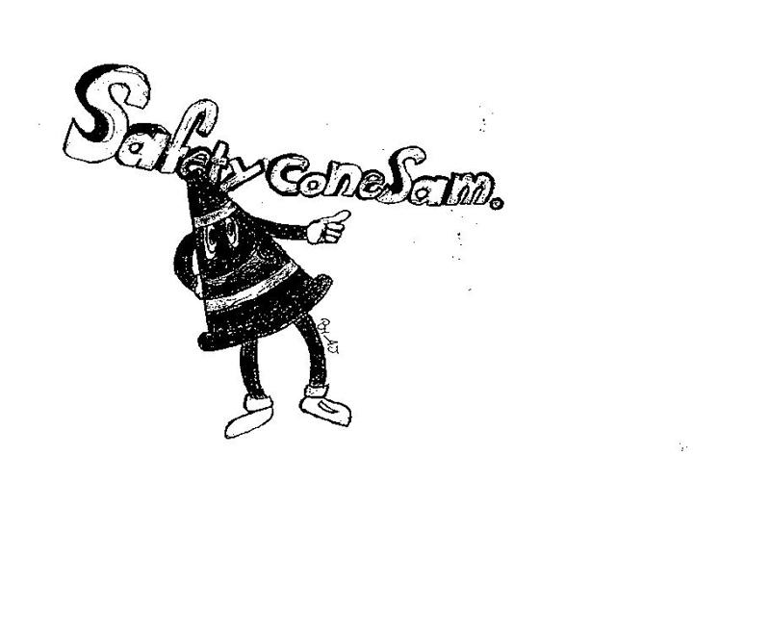
SAFETY FIRST

PERRY TOWNSHIP SCHOOLS
EMPLOYEE SAFETY NEWSLETTER
NOVEMBER 2017

DON’T LET THIS HAPPEN TO YOU!
Here are descriptions of two recent accidents in our township:
- An employee was recently injured while walking through the hallway. He was struck by a classroom door that was opened abruptly by a student in a hurry to get to class. In some of our buildings, doors open outward into the hall. Always be on the lookout especially during passing periods.
- It seems falls can happen anywhere under any conditions. A recent fall occurred to one of our employees who was walking up steps. The bottom of her sandal got caught on the top of the step causing her to trip. Be aware of where you are walking at all times.

WATCH OUT—COLD ICY MORNINGS ARE COMING!
They are close and we will continue to have surprises some mornings. No matter how well the snow and ice is removed from parking lots or sidewalks, you will still encounter slippery surfaces when walking on those cold and wet days. It is important for everyone to be constantly aware of these dangers and to learn to walk safely on ice and slippery surfaces.
- Keep appropriate footwear in your car. Spikes are best on ice and snow.
- In cold temperatures, assume you may encounter ice on your way into the building.
- Use designated walkways when possible.
- Look ahead--avoid obvious areas that look icy. Remember, grass can be safer than an icy patch on a sidewalk.
- Walk like a penguin--Point your feet slightly.
  - Walk flat footed with your center of gravity directly over the feet as much as possible.
  - Extend your arms out for balance. Don’t carry a lot under icy condition. You may need your hands to soften a fall.
  - Go SLOWLY.
  - Take short steps or shuffle.
- Be especially careful when entering or exiting a vehicle. Look down to be sure you are not on an icy patch.

NEW INCENTIVES FOR A JOB WELL DONE
The employee safety committee would like to acknowledge the efforts that many of our staff make to achieve fewer accidents each year. We have always had one annual award that recognizes the building with the fewest number of accidents. However, it is impractical for buildings with larger staffs to win this type of award when competing with a small building with a fraction of the number of employees. In order to recognize the safety efforts being made by employees in larger buildings, the committee recently adopted a new incentive award program. The new incentives which will be awarded for the accident reporting period between July 1, 2017 to June 30, 2018 are as follows:
- A banner as awarded in the past to the building with the fewest injuries for the year.
- A certificate to the building with the most significant reduction in the number of injuries by percentage.
- A certificate for the buildings that show an improvement in lowering injuries from one year to the next.
This incentive program will continue each year. The committee wants to extend our thanks to all of you who take safety seriously and work to achieve an accident-free workplace.

EXTREME COLD WEATHER IS HAZARDOUS
Serious health problems can result from prolonged exposure to the cold. The most common cold-related problems are hypothermia and frostbite.
Hypothermia occurs when people are exposed to cold temperatures. A person’s body begins to lose heat faster than it can be produced and prolonged exposure to the cold will ultimately use up a body’s stored energy. This results in hypothermia, or abnormally low body temperature. Body temperature that is too low affects the brain, making the victim unable to think clearly or move well. This makes hypothermia particularly dangerous because a person may be unaware it is happening and won’t be able to take protective measures.
Frostbite is an injury to the body that is caused by freezing. Frostbite causes a loss of feeling and color in affected areas. It most often affects the nose, ears, cheeks, chin, fingers, or toes. Frostbite can permanently damage the body, and severe cases can lead to amputation. The risk of frostbite is increased in people with reduced blood circulation and among people who are not dressed properly for extremely cold temperatures.
If you detect symptoms of frostbite, such as numbness, waxy-feeling skin, or a white or gray colored area of skin, do not rub the area. Instead, get into a warm room as soon as possible. Gently warm the affected area with comfortably warm (not hot) water, or place the affected area next to a warm part of your body, for example your armpit. Never use a heating pad or other source of heat to warm frostbitten body parts as these areas are numb and can be easily burned. Seek care from a health care professional immediately.

EMPLOYEE ACCIDENTS IN OCTOBER
- An employee was removing a pumpkin from a refrigerator and tripped over a milk create causing a knee injury.
- An employee was struck on the arm by a moving vehicle in a parking lot causing an elbow injury.
- An employee tripped on an ottoman and fell injuring her knee.
- A student struck the shoulder of an employee.
- An employee tripped on the steps of a bus causing an ankle injury.
- An employee was struck by a door causing facial lacerations.
- An employee suffered an injury to her hip, arm, shoulders, and knees after slipping on a wet sidewalk.

