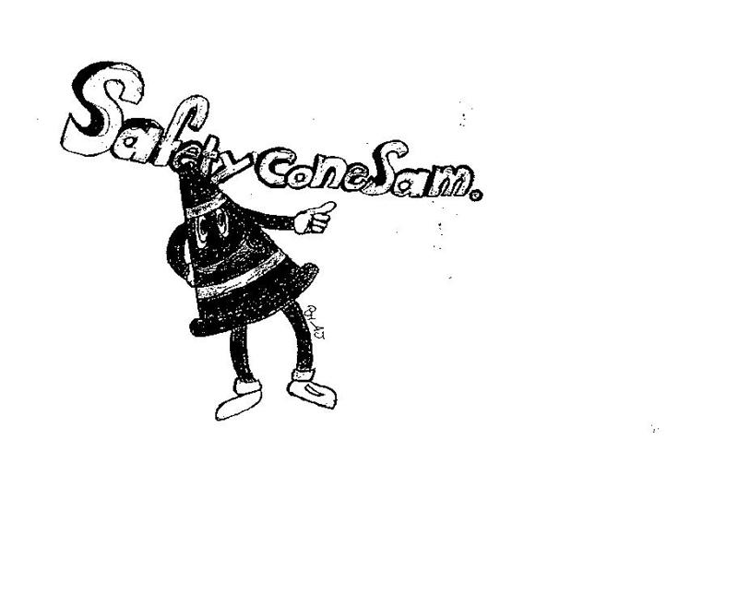
SAFETY FIRST

PERRY TOWNSHIP SCHOOLS
EMPLOYEE SAFETY NEWSLETTER
MAY 2018
DON’T LET THIS HAPPEN TO YOU!
Here are descriptions of two recent accidents in our township:
- An employee slipped as she walked from carpet onto a tiled area of flooring. She landed on her side causing injury to her ankle and shoulder. Transitioning from carpet to a smooth surface is a common slip hazard. You can help minimize this hazard by wearing slip resistant shoes. Regardless of the type of shoes that you wear, always pay attention to where you are taking your next step.
- After lifting a pan of meat from an oven, an employee felt pain in her arm and elbow. The pain was the result of too much stress from the weight of the meat. The corrective action taken by the manager is to be sure all of her staff reduce the amount of meat that is in a pan at the same time. Be cognizant of the load you are carrying. It is better to make more trips with less weight than to suffer the consequences.

SPRING IS HERE—BE SAFE!
If spring cleaning is on your to-do list this month, it is important to work safely, whether you are simply clearing winter debris from your lawn or tackling a major renovation project. Here are some simple steps you can take to ensure that you are protecting yourself, your family and the environment as you check off the chores on your list.
LADDER SAFETY
Ladders can be hazardous when not used properly. In many cases, accidents and injuries occur while using ladders because they are improperly placed, not secured, not the right size for the job or the user overreaches. When working with ladders always remember to:
• Read and follow all warning labels that are on the ladder.
• Use ladders only on solid, stable and level surfaces.
• Keep your body centered on the ladder. Never lean over either side rail.
• Never stand on the top two rungs of a stepladder.
• Only use a stepladder in a fully opened and locked position. Never use it while it is closed, partially opened or leaning on a structure.
• Protect yourself from electrical hazards and do not work within 10 feet of overhead power lines.

MOVING HEAVY OBJECTS
Spring cleaning often involves moving heavy objects such as couches, tables, entertainment consoles and bookcases. A serious injury can occur in these situations, too. In order to eliminate the risk of objects falling and to lift items safely, always have another person help you. More tips for lifting heavy objects include:
• Get close to the load.
• Maintain an upright posture from the waist up.
• Lift with your legs, not your arms or back.
• Pivot on your feet; do not twist from your waist.

USE THE W.H.A.T METHOD TO PREVENT INJURIES WHEN LIFTING. From Supervisors Safety Bulletin
W=Weight—Is there any way I can break down this load into smaller, easier to carry loads?
H=Height—Is the object at table level so I don’t have to bend over and pick it up off the ground?
A=Assistance—Is there anyone who can help me?
T=Terrain—Is the path I’ll be walking free of any hazards so I have a clear line of sight?

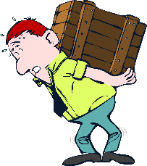
CLEANING PRODUCTS
Using chemicals during cleaning can pose a hazard to not only you, but also to the environment. Read the labels of all chemicals you are using and follow all the recommended safety practices. These may include wearing protective gear such as gloves and goggles, not mixing the substance with other cleaners, opening windows for ventilation, and following proper disposal guidelines.

Consider using all-natural cleaning products that can be equally effective than their traditional counterparts. Be sure to read all the labels on these products, as well, to ensure that they truly are green. Natural cleaning products that you may already have in your cabinet include baking soda, lemon juice and white vinegar.

YARD TOOLS
Make sure you have properly maintained any tools or equipment in accordance with the manufacturer’s recommendations. Have your lawnmower serviced yearly, never remove guards or safety devices, and wear appropriate eye, body, and hearing protection.

EMPLOYEE ACCIDENTS IN APRIL
- While assisting a student exiting a bus, an employee sustained a thumb injury.
- An employee sustained an elbow injury after lifting a heavy load.
- A student bit an employee on the hand.
- A student kicked an employee on the chin.
- An employee tripped over a student and fell backwards causing a back injury.
- An employee suffered a fractured finger after catching a kickball.
- After bending over to pick an item from the floor, an employee backed into an open drawer causing injury.
- A frame fell from a wall striking an employee while she was hanging artwork.

