Sianginn i rawl eimi sawknak ding kong  - Alak le Man tlawmdeuh in rawl einak ding sawknak hi Online in phi uh!  - Rianrang le fawite in a dot dot i sawknak  - Phan ding um lo – nan konglam hi himte in fim a si  - Rianrang deuh in pompiak khawh a si  - A ṭhat cemnak cu, a hman man pek a hau lo  Nan fa hi alak siloah man tlawmdeuh in rawl ei khawhnak hi a ngah khawh men. Hi catlap ah alak siloah man tlawmdeuh in rawl einak ding online in sawk ning hi a um lai. Catlap in sawk nan duh si ahcun, nan fale kainak sianginn zung fawn ah chawn tehna uh. A sawk ning nan fian lo siloah bawmh nan herh ahcun 317-789-3715 ah rak chawn te uh  Nan inn chungkhar phaisa hmuhmi zat hi rikhiahmi chung i a um ahcun..  ZAANGFAH TEIN ATU SAWK!  PLEASE APPLY NOW!  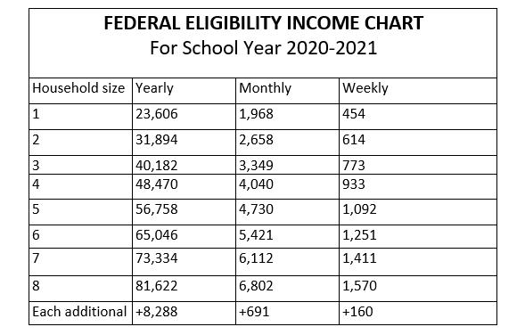  Chin  Updated 6/17/20 | 1. District website www.perryschools.org ah hin lut  2. Skyward hi hmet  3. Skyward luhnak ah nan firstname.lastname le password. Nan tial lai i nan lut lai. Skyeard Family Access ah voi 1 hmanh nan luh bal lo ahcun, nan password ah “skyward” nan hman lai i avoi khatnak nan luh in thlen colh a herh lai  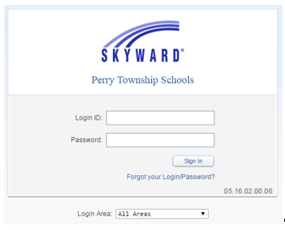  4. Skyward i nan luh in acung lei kehlei kil i “Family Access” tangah siangngakchia min khumhmi an um lai i pakhat khat min thim ta hmasa ding  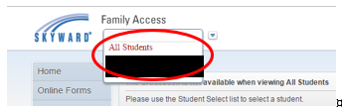  5. Food Service ti zawn hi hmet cun Applications hmet than  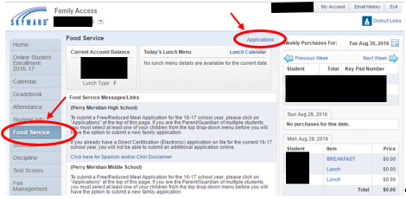 | 6. Add Application ti zawn hi hmet than  7. (Nulepa caah a sawk ningcang tialpiakmi ca, federal income Chart, Privacy Act Statement le Non-Discrimination Statement) hi thatein zoh hna law pakhat na tuah dih paoh in next hi hmeh/click te. Instruction for Applying tang I I have read the instructions for Applying and would like to continue the application hi hmet  8. Sawknak  Step 1: Nan inn chungkhar minung zat; bawhte ngakchia, le taang 12 tang siangngakchia dihlak an min tial hna  Step 2: Nangmah siloah nan inn chungkhar ah pakhat khat paoh SNAP(Food Stamp) TANF siloah Medicaid a ngahmi an um ahcun nan case number tial  Step 3: Nan inn chungkhar phaisa hmuhmi zat tial  Step 4: Minthut  Step 5: Adang benefits – Miphun le chuahkehnak dang sinak  Na sawknak hi zoh than ta law ap te!

