Nulepa Nih COVID-19 Chekpiak Ding

Nan fa sianginn a kai hlan ah atang lei bantuk in a zaw maw ti chek ta lengmang uh:

Nan fa a taklinh (fever) dikari 100.4 asiloah naak sang a si maw.
1
Nai hrawng ah atang lei zawtnak bantuk phun hi a ngei maw:
2
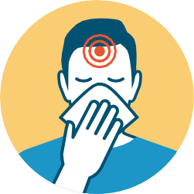
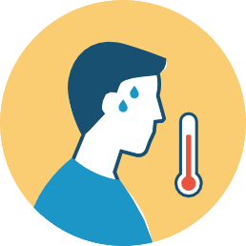
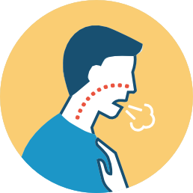
CHUNGTLIK
THAW PIH ASILOAH
THAWCHUAH HAR
KHUH
CUMPI ASILOAH
HNAPDI TLAAK
TAKLINH 100.4*

RAWL TAHWNAK THEIH LO
ASILOAH THIL RIM THEIH LO
TAK KIH
THAHRI FAH
LE THADIH
LUAKCHUAH
ASILOAH LUAK
HROM FAH
LUFAH

Kan hnu zarh hnih chung ah COVID-19 zawtnak a ngei ti hngalhmi he (pe 6 naak nai in minutes 15 chung) an um ṭi maw?
3
AN UM ṬI AHCUN, nan fa hi sianginn KAITER LO ding. Inn ah umter ding le siibawi (healthcare provider) le Principal chimhpiak ding. CIVID-19 zawtnak a ngeih le ngeih lo test tuahternak ruahpiak ding.
>
COVID-19: Zeitik in dah student, faculty le staff sianginn an kai khawh ṭhan lai
SCHOOL

Pumpak (Individual)
SCHOOL
Test ai tuah lomi, a dang chimhmi (hromfah, cumpi tlangrai phun a ngei tiah sibawi nih a timi)

Test ai tuah lomi, a dang
chimhmi a um lomi

Test ai tuahmi le a ngei lomi
(Tested and Negative)

Test ai tuahmi le a ngeimi
(Tested and Positive)

COVID-19 zawtnak a ngeimi pakhat khat he pe 6 naak naih in minit 15 chung a ṭhudir ṭimi

Zawtnak a langmi (Symptomatic)
Suimilam 24 chung a taklinh a um ti lo hnu LE siibawi nih a damlo nak hi zawtnak phun dang a si, sianginn kaiter khawh ṭhan ding a si ko ti a zumh i ca (email le fax tel in) a ṭialpiak ahcun sianginn kai khawh ṭhan a si lai.

Zawtnak (symptoms) ai thawkka in a tlawmbik ni 10 chung cu inn ah umter ding LE suimilam 24 chung sii ding lo in a taklinh ti lo le a zawtnak muisam (symptoms) a um ti lo tiang inn ah um rih ding

- A dang an chimhmi a um lo ahcun, a zawtnak (symptoms) ai thawkka in ni 10 chung cu a dangte i umter ding LE sii ding lo in suimilam 24 chung a taklinh ti lo le zawtnak (symptoms) a ngeihmi a ṭhat deuh tiang inn ah um ding.
OR
- Test an tuah i zawtnak a ngeih lo (negative a si) LE a damlonak hi zawtnak phun dang a si, sianginn kaiter ding a si ko tiah sibawi nih ca a ṭialpiak ahcun sianginn kai ṭhan khawh a si lai.

Zawtnak (symptoms) a langh ai thawk in a tlawmbik ni 10 chung
cu inn ah a dangte in umter ding LE sii ding lo in suimilam 24
chung a taklinh ti lo le zawt langhnak (symptoms) a ṭhat deuh
tiang inn ah um ding.
(CDC nih test-based strategy hman ding hi thil herh ngaimi a ruang a um theng lo ahcun tuah a herh an ti lem loh)

N/A
Zawtnak muisam ngeimi (symptomatic) a si ahcun, muisam langhnak (symptomatic scenarios) he zoh ṭhimh ding. COVID-19 ngeimi he a ṭhudir ṭimi a si ahcun zawtnak dang i a damlo mi a si zong ah ni 14 chung ah amah lawng in umter le erhkhumh ding.

Zawtnak a lang lomi (No Symptoms)
N/A

N/A

Sianginn kaiter ṭhan khawh ding a si lai.
FIANTER NAK: Zawtnak ngeimi he i naihte in (pe 6 naak nai in minit 15 chung) a ummi a si ahcun COVID-19 zawtnak hi ai test ter i negative a si ko zong ah ni 14 chung cu hmun dang ah umter ta ding hrimhrim a si lai.

Test ai tuah ni thawh in ni 10 chung cu amah
lawng a dangte in umter (isolate) ding.
(CDC nih test-based strategy tuah ding hi thil herh ngaimi a ruang a um dah ti lo ahcun an duh lem lo)
*Zawtnak muisam (symptoms) a ngeih ahcun, amah lawng umter caan hi symptoms a langhmi a ni 1 nak in ai thawk lai. (symptomatic tests positive zoh uh)

Sianginn kai hlan ah ni 14 chung amah lawng erhkhumh ding. Zawtnak muisam a ngei ti lai lo (symptom-free). Zawtnak muisam langhnak a ngeih ahcun zawtnak muisam langhnak pawl he zoh kep ding.

Fianternak: ERHKHUMH (QUARANTINE) hi COVID-19 zawtnak ngeimi he a ṭhudir ṭimi minung midang he i cawh lo dingin hmun dang ah umter a si.
A DANGTE IN CHIAH (ISOLATION) cu a damlomi asiloah COVID-19 zawtnak a ngei nain zawtnak mui (symptoms) a lang lomi a dangte in umter a si, an mah inn a si zong ah.

