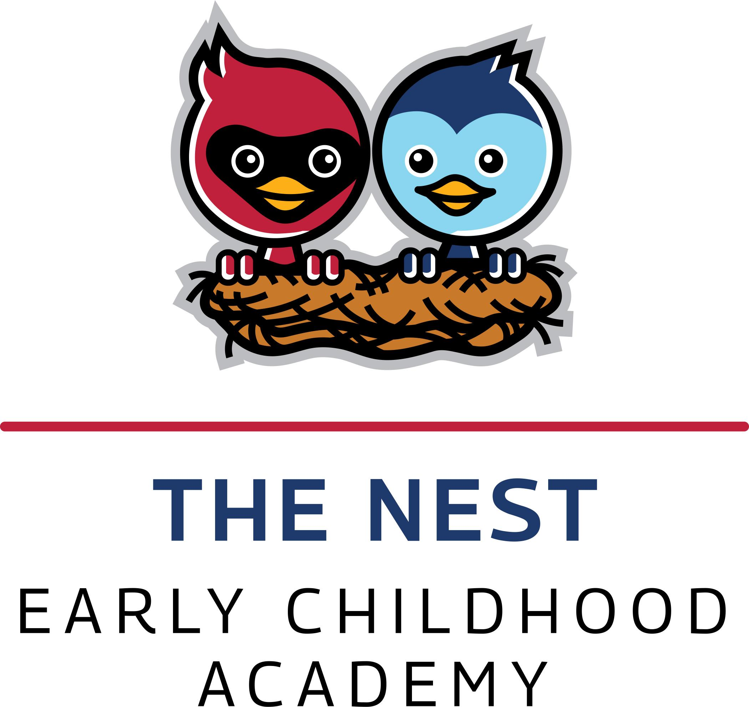

6548 Orinoco Avenue●Indianapolis, IN 46227 ● (317)789-3900●Fax (317)780-4408

Mr. Anthony Osborne Mrs. Savanah Holland Mrs.Samantha Dillman

Principal Treasurer Secretary

**Perry Township Early Childhood Academy Discipline Policy**

It is very important that a child’s development is nurtured through caring, patience and understanding. We teach the whole child and help children learn how to be successful in school and with their friends. While caring for your child, I may have to respond to his/her misbehavior. Hitting, kicking, spitting, hostile verbal behavior and other behaviors which will hurt another child or staff are not permitted.

In response to these behaviors, I will not use:

-Threats or bribes  
- Physical punishment, even if requested by the parent  
- Humiliation or isolation

In response to misbehavior, I will:

- Respect your child  
- Establish clear rules  
- Be consistent in enforcing rules  
- Use positive language to explain desired behavior  
- Speak calmly while bending down to your child’s eye level  
- Give clear choices  
- Redirect your child to a new activity  
- Move your child to a time-out area for no longer than one minute per year of your child’s age, if necessary

If your child’s behavior is very disruptive or harmful to themselves, staff or other children, we will discuss the issue with you privately. If the situation can be resolved, the child may remain enrolled. If we are unable to resolve the issue, it may be determined that the Early Childhood Academy is not an appropriate placement for your child and you may be asked to make other arrangements.

As a parent, you may have some concerns or wish to offer suggestions. Using the lines below, we may modify the above plan with agreed upon suggestions.

_____________________________________________________________________________  
_____________________________________________________________________________

Child’s Name _____________Date of Birth_______________ Teacher _____________________

Parent/Guardian Signature __________________________________ Date _______________

6548 Orinoco Avenue●Indianapolis, IN 46227 ● (317)789-3900●Fax (317)780-4408

Mr. Anthony Osborne Mrs. Savanah Holland Mrs.Samantha Dillman

Principal Treasurer Secretary

**Perry Township Early Childhood Academy Chimhhrinning Phunglam**

Hngakchia pawl hi tthat tthan in an than khawh nak dingah dawtnak, thinfualnak le theihthiamnak in zohkhenh hi a biapi ngai mi a si. Si na in, dawtnak kan ti tikah, tthatlonak an tuah ahcun a herh ning in chimhhrin ding hi kan rian a si fawn. Mi va bengh, va chiuh, cil va chak, biathalo hman le mifahnak tuah cu sianginn nih a pom mi phunglam si lo.

Hngakchia nih hibantuk ziaza an ngeih ahcun, a tanglei chimhhrim ning hi sianginn nih **kan hmang lai lo**;

-Tlerh/khonh, phaisa phalh in duhnak tuah ter  
- Taksa fak dihlak in velh le fung in tuk (nu/pa nih tuah ter zongah)  
- an ningzahnak ding in chimhhrin

Hngakchia chimh an ngeih lo ahcun, a tang lei bantuk in **kan chimhhrin hna lai**;

- Hngakchia upatnak he kan chimhhnrin hna lai.  
- Umtu ningcang an lungtliang ding in kan chimh hna lai.  
- Nawlngai ding in kan cawnpiak hna lai.  
- Atha mi bia hmang in kan chimhhrin hna lai.  
- An mitfang tha te’n zoh in awnem te in kan sik hna lai..  
- Duhthimnak kan pek fawn hna lai.  
- Cawnnakthar tha te’n kan fianh hna lai.  
- Dantat thutternak caankhiah mi cu Hngakchia an kum hoih in a si lai. Na fa kum nga a si ahcun minute 5 kan thut ter lai, kum li a si ahcun minute 4 si ve lai.

Chimhkhawh lo tiangin le midang fahnak an tuah lengmang ahcun, nu/pa auh in I ceih nak a um lai. Cuti kan in auh hna hnu ah, an that deuh hlei lo ahcun sianginn in kan chuah hna lai. An that deuh ko ahcun kan sin ah kum dih tiang an kai lai.

Nu le pa nan si bantuk in, hi ziaza chimhhrinnak kong he pehtlai in ruahnak cheuh nan kan duh mi um ahcun a tang ah rak tial uh. Nan ruahnak le a cung I kan tial mi kan policy pawl hi kan fomhtonh lai I a tha bik mi chimhhrinnak in hngakchia kan zohkhenh han lai. _____________________________________________________________________________  
_____________________________________________________________________________

Hngakchia Min _____________Chuah Ni_______________

Nu/Pa Minthut __________________________________ Date ____

