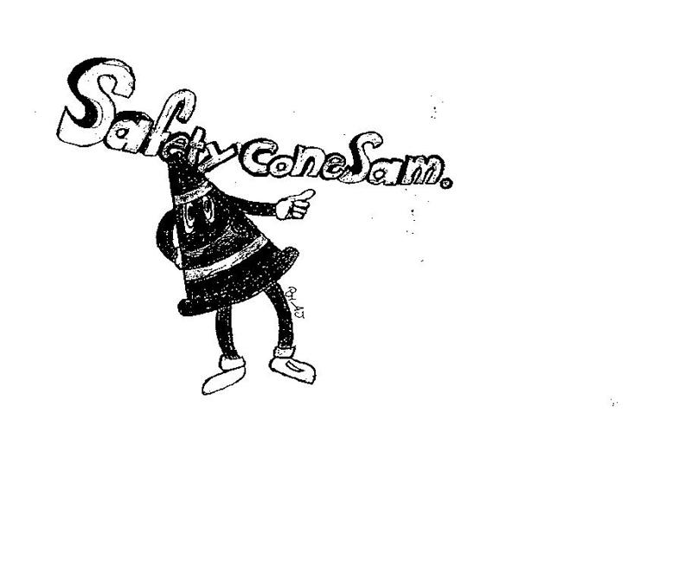
SAFETY FIRST

PERRY TOWNSHIP SCHOOLS
EMPLOYEE SAFETY NEWSLETTER
JANUARY 2018

WALKING SAFELY ON ICE
Walking to and from parking lots at work during the winter requires special attention to avoid slipping and falling. Slips and falls are some of the most frequent types of injuries that the Employee Safety Committee sees — especially during the winter months.
No matter how well the snow and ice is removed from parking lots or sidewalks, we will still encounter slippery surfaces when walking outdoors in the winter. It is important for everyone to be constantly aware of these dangers and to learn to walk safely on ice and slippery surfaces.
Please review these safety tips:

Walking Over Ice
- In cold temperatures, approach with caution and assume that all wet, dark areas on pavements are slippery and icy. Dew or water vapor can freeze on cold surfaces, forming an extra-thin, nearly invisible layer of ice that can look like a wet spot on the pavement.
- Walk in designated walkways as much as possible. Taking shortcuts over snow piles and other frozen areas can be hazardous. Look ahead when you walk; a snow- or ice-covered sidewalk or driveway, especially if on a hill, may require travel along its grassy edge for traction.
- If you must walk in the street, walk against the flow of traffic, as close to the curb as you can.
- Taking shortcuts through areas where snow and ice removal is not feasible can be hazardous. Try to avoid straying from the beaten path.
- Point your feet out slightly like a penguin! Spreading your feet out slightly while walking on ice increases your center of gravity.
- Bend slightly and walk flat-footed with your center of gravity directly over the feet as much as possible.
- Extend your arms out to your sides to maintain balance. Beware if you are carrying a heavy backpack or other load—your sense of balance will be off.
- If you must carry a load, try not to carry too much; leave your hands and arms free to balance yourself.
- Keep your hands out of your pockets. Hands in your pockets while walking decreases your center of gravity and balance. You can help break your fall with your hands free if you do start to slip.
- Watch where you are stepping and GO S-L-O-W-L-Y !! This will help your reaction time to changes in traction.
- When walking on steps, always use the hand railings and plant your feet firmly on each step.
- Use special care when entering and exiting vehicles; use the vehicle for support.
- Take short steps or shuffle for stability. It also helps to stop occasionally to break momentum.

Choosing Appropriate Clothing
- During bad weather, avoid boots or shoes with smooth soles and heels, such as plastic and leather soles. Instead, wear shoes or boots that provide traction on snow and ice; boots made of non-slip rubber or neoprene with grooved soles are best.
- Wear a heavy, bulky coat that will cushion you if you should fall.
- Wear a bright scarf or hat or reflective gear so drivers can see you.
- Keep warm, but make sure you can hear what's going on around you.
- During the day, wear sunglasses to help you see better and avoid hazards.
- Whatever you wear, make sure it doesn't block your vision or make it hard for you to hear traffic.

Indoor Safety
Walking over slippery floor can be just as dangerous as walking over ice! Keep these tips in mind if you are entering a building:
- Remove as much snow and water from your boots as you can. Water from melting ice on the floor can lead to slippery conditions.
- Notice that floors and stairs may be wet and slippery—walk carefully especially by outer doors.

If You Should Fall
- Try to avoid landing on your knees, wrists, or spine. Try to fall on a fleshy part of your body, such as your side. Wearing thick clothing can help prevent injury to the bony parts of your body.
- Try to relax your muscles if you fall. You'll injure yourself less if you are relaxed.
- If you fall backward, make a conscious effort to tuck your chin so your head won't hit the ground with full force.
EMPLOYEE ACCIDENTS IN NOVEMBER AND DECEMBER
- A student threw a plastic container which struck an employee on the head.
- A student jammed a chair into an employee’s foot causing injury to her foot and toes.
- An employee punctured her finger while removing a rubber band from a group of pencils.
- An employee exerted too much force while removing an oil filter and injured his arm.
- While transferring a student from a wheel chair to a chair, an employee injured her wrist.
- A hot liquid splashed onto an employee’s arms when she removed a pan from a microwave.
- An employee sustained a back injury from lifting a crate from the floor to a cart.
- An employee sustained a thumb injury while breaking up an altercation between students.
- An employee grabbed a bus steering wheel awkwardly while turning and injured her shoulder.
- An employee suffered a head injury while spotting a cheerleader doing a back flip.
- An employee received an eye injury when a student tried to stop a ball.
- An employee injured his back while mopping a floor.
- An employee hit his head on a broken door panel.
- A student scratched an employee who was bringing the student into the building.
- While playing a team building game, an employee fell and sustained a knee injury.
- An employee cut her hand while putting dishes away.

