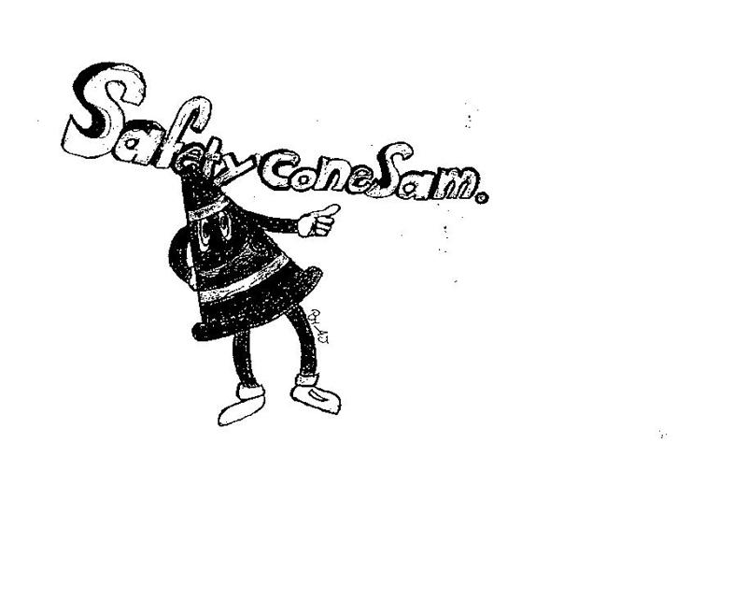
SAFETY FIRST

PERRY TOWNSHIP SCHOOLS
EMPLOYEE SAFETY NEWSLETTER
MARCH 2018
DON’T LET THIS HAPPEN TO YOU!
Here are descriptions of two recent accidents in our township:
- While returning to her work station, an employee was grabbed by a young student she saw on the floor, but did not see reach for her legs. This caused her to fall forward into a desk and sustain facial bruising and a broken nose. Each year, similar accidents are reported where an innocent student causes employees to trip and fall. Keep a look out—they are small, quick, and unpredictable.
- While escorting students to their bus pick up location, an employee tripped and fell causing bruising and soreness that lasted a few days. Upon further review the employee said she was walking backwards to be sure her students were in line and not wandering into the line of cars. It is understood that many staff members walk backwards every day as part of their job. But please do not forget to keep an eye where you are going. Sidewalks and even hallways are sometimes hazardous and the result can be very painful.

KEEP SAFE THIS VACATION?
Spring weather is close at hand. That means you might be spring housecleaning, rearranging the garage, or even moving boxes out of your classroom for storage elsewhere. Some of you will soon be moving into different classrooms. Here are some tips to keep you injury free while performing those tasks.

LIFT SAFELY
Moving objects from one place to another is a common task. Pushing, pulling and lifting can be done effortlessly and safely with thoughtful planning. Your body is like any other tool or piece of equipment. The job can be easily accomplished if you keep moderately fit and focused.
Know your physical limitations and remember these guidelines.
- Be realistic when assessing the load. Plan the move in your mind before you begin the physical task. If you think the load is too bulky or heavy, it is.
- Never store heavy objects higher than your shoulders. Lifting even the lightest objects over one's head puts additional strain on the back.
- Ask for assistance or break the load into smaller, more manageable sizes.
- Use carts when possible.
- Warm-up your back and leg muscles. Learn some simple stretching exercises.
- To lift properly:
  - stand close to the object with your feet about a shoulder width apart.
  - Squat down, bending at the hips and knees. Keep your back straight and rise looking forward.

  - Grip the load, arch your lower back inward and rise slowly. Again, keep the load close to your body.
  - Avoid twisting your torso while carrying a load. Turn your whole body in the direction you want to go. Twisting places addition stress and strain on the spine and back muscles.
  - To lower the load, squat first, bending naturally at the hips and knees. Keep your lower back arched inward.
TAKE CARE OF YOUR KNEES AND BACK 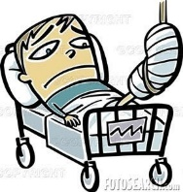
- Proper exercise will strengthen your knees, back and abdominal muscles.
- Know proper lifting procedures and use them each and every time you lift
- Wear proper back support when lifting.
- Practice good posture. You'll have a stronger, healthier back and you will look and feel better.
- Watch your weight and practice good nutrition.
- Sit in a chair that adequately supports your back. Try to sit with your knees higher that your hips.

USE TOOLS SAFELY
- Examine electrical cords for exposed wires and/or defective plugs.
- Wrap extension cords neatly and store when not in use. Extension cords are not to be used in place of permanent wiring.
- Each tool should be stored in a designated place/space when not in use.
- Familiarize yourself with power tools BEFORE you use them. Never use a tool you are unfamiliar with. Never perform work for which you have not been trained.
- When all else fails, read the USERS MANUAL BEFORE using the tool.
- Prepare the work area. Whenever possible restrict access to the work area and stay mindful of others around you.
EMPLOYEE INJURIES IN FEBRUARY
- A student kicked an employee’s leg out while the employee was standing causing a knee injury.
- An employee was in an auto accident while working for the township.
- An employee sustained a back injury while removing an overhead motor.
- An employee slipped and fell on a slippery tiled floor.
- A bus door closed on an employee causing a head injury.
- An employee sustained a knee injury while pushing a student on a swing.
- An employee tripped on a co-worker’s foot and fell injuring her knee.
- A student pulled a chair away as an employee attempted to sit causing head and back injuries.
- An employee cut her finger on a slicer.
- An employee chocked on her lunch.
- An employee tripped over a student and hit her head.

