MINUTES OF A

PUBLIC WORK SESSION

OF THE BOARD OF EDUCATION
OF
PERRY TOWNSHIP SCHOOLS
MARION COUNTY, INDIANA

January 27, 2020

The Board of Education of Perry Township Schools, Marion County, Indiana, held a Public Work Session on Monday, January 27, 2020 at 6:00 p.m. at the Perry Township Education Center, 6548 Orinoco Avenue, Indianapolis, Indiana.

Board of Education members present:

Steve Johnson, Board President
James H. Hernandez, Board Vice President
Lee T. Shively, Board Secretary
Hannah H. Dale, Board Member
Emily Hartman, Board Member
Charles R. Mercer, Jr., Board Secretary
Ken Mertz, Board Member

Administrative staff present:

Mr. Patrick W. Mapes, Superintendent
Mr. Chris Sampson, Associate Superintendent of Operations
Mr. Bob Bohannon, Assistant Superintendent of Career Preparation, 6-12
Mrs. Vickie Carpenter, Assistant Superintendent of Foundational Learning, Pre K-5
Mr. Kent Hatcher, Chief Financial Officer
Mr. Matthew Willey, Chief Technology Officer

OPEN PUBLIC WORK SESSION
Mr. Johnson called the Public Work Session to order at 6:00 p.m.

SCHOOL PERFORMANCE
Mr. Bob Bohannon and Mrs. Vickie Carpenter presented data on school performance.

TSL GRANT
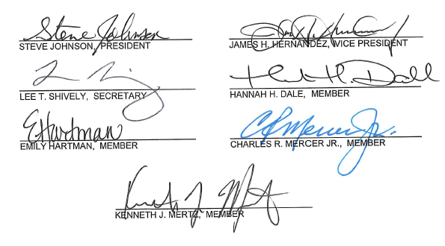
Mr. Bohannon and Mrs. Carpenter presented information on the TSL grant.

ADJOURNMENT
Mr. Johnson adjourned the Public Work Session.

