ATTENTION
Have you visited a country that has had a Coronavirus outbreak in the last
14 days
OR
had contact with somebody with Coronavirus?
AND
Do you have any of these symptoms?
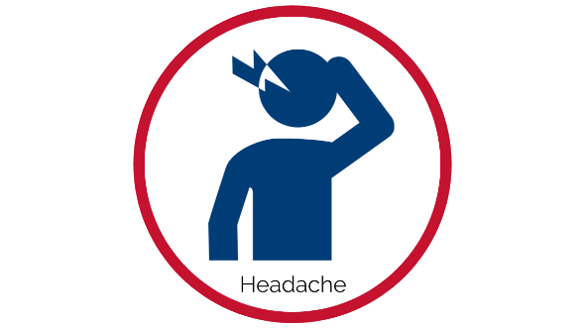
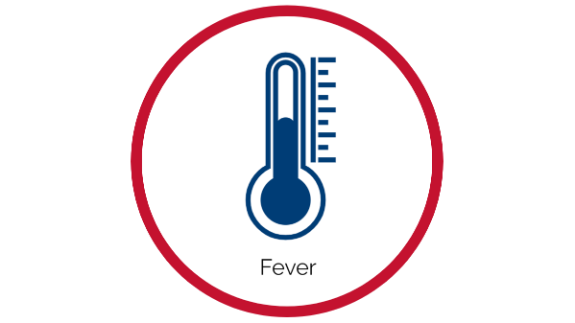
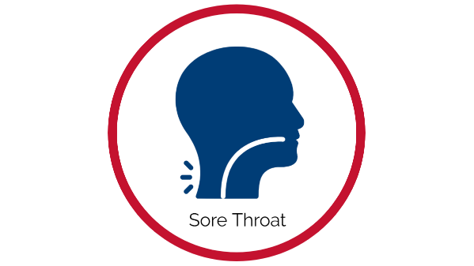
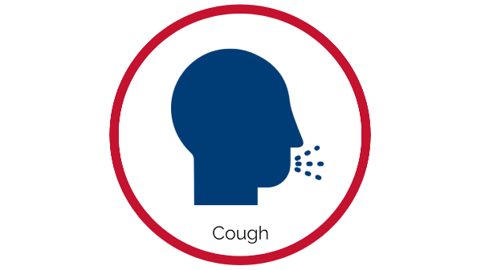
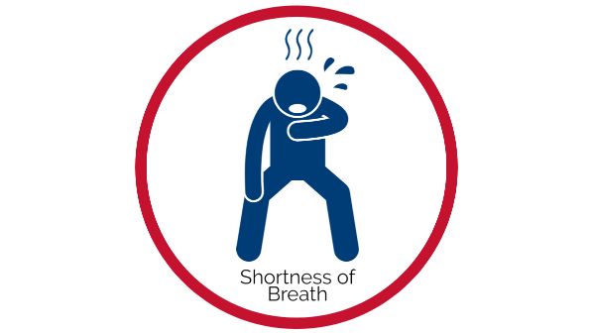
If yes, please reschedule your visit.
Contact your child’s school if you have additional questions.

